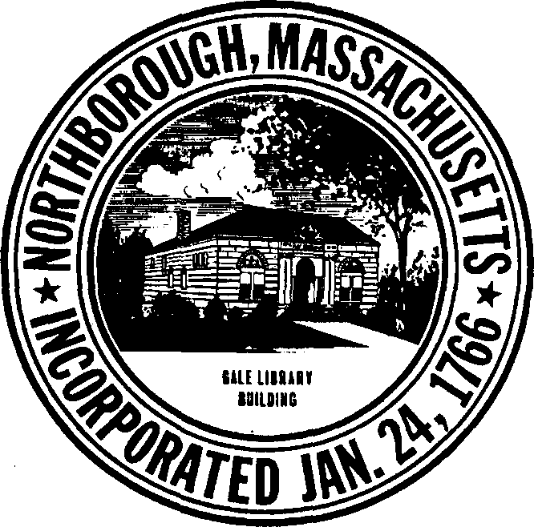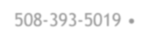
TOWN OF NORTHBOROUGH PLANNING DEPARTMENT
Town Hall Offices • 63 Main Street • Northborough, MA 01532 • 508-393-5019 • 508-393-6996 Fax

Procedural Sheet & Comments

Common Driveway Special Permit Site Plan Approval
Special Permit in Industrial
Special Permit per Groundwater Protection Overlay District Bylaw Wireless Communications Facility Special Permit
Wireless Communications Facility Site Plan Review

- Sixteen (16) copies of the attached application form, adopted by the Board for this purpose, shall be prepared for site plan review, special permit site plan review, common driveway special permit, wireless communications facility site plan review and wireless communications facility special permit applications. Note: Regarding site plan review applications, an additional 5 copies are required if the proposal is located within the BA district. Sixteen (16) copies of all attachments and exhibits, including the following, shall accompany the form:
  - Prints of the latest recorded plan of the land which will be affected; or in cases where no such plan exists, prints of a plan of the land which will be affected; or in cases where no such plan exists, prints of a plan of the land endorsed by a registered engineer or land surveyor. The plan shall include the details as outlined in the applicable zoning bylaw.
  - Certification from the Northborough Board of Assessors, and, if indicated by the Northborough Board of Assessors, also by one or more Boards of Assessors of abutting towns, listing the names and addresses, as they appear on the most recent local tax list, of the owners of all abutting property and other “parties of interest” in accordance with M.G.L. Ch. 40A Sec. 11.
  - Copy of the latest recorded deed to the property which will be affected.
- All pertinent paragraphs of the application must be completed, and all information required by the form shall be concisely stated. If there is insufficient space on the form, additional sheets may be attached bearing the applicable paragraph number and containing the additional information.
- The original of the form shall be signed personally by the applicant(s) and an acknowledgement thereof made before a Notary Public.
- Each application must be accompanied by a filing fee payable to the Town of Northborough. Refer to the Planning Board Rules & Regulations for a complete fee schedule. The forms and fee must be presented at the office of the Town Clerk at the times and dates designated by that office.

- Additional documents may be submitted at the public hearing.

- The Planning Department will be responsible for the publication of the public hearing notice and the notification to the abutters.
- Site Plan Review: The plan of review for a site plan approval (no special permit involved) shall be no longer than ninety (90) days from the date of submission of the application unless the period is extended through written mutual agreement between the Planning Board and the applicant. The Planning Board may hold a public information meeting during that period.
- Common Driveway Special Permit: In accordance with M.G.L. Chapter 40A Section 9, the Planning Board shall hold a public hearing within 65 days from the date of the filing of the application and a decision shall be made within 90 days from the close of the hearing, unless the period is extended through written mutual agreement between the Planning Board and the applicant.
- Wireless Communications Facility Special Permit: In accordance with M.G.L. Chapter 40A Section 9, the Planning Board shall hold a public hearing within 65 days from the date of the filing of the application and a decision shall be made within 90 days from the close of the hearing, unless the period is extended through written mutual agreement between the Planning Board and the applicant.
- PLEASE NOTE: If a proposal is in the BA or BB zoning district, 5 additional copies of the application and plan shall be submitted to the Design Review Committee. If a proposal is in the Groundwater Protection Overlay District, 5 additional copies of the application, plan and drainage calculations shall be submitted to the Groundwater Advisory Committee.
- Completed distribution sheets must be returned to the Town Planner prior to receiving an agenda date and time.

NOTE: The Planning Board, in its discretion, may dismiss an application (without prejudice) for failure to comply with any of the foregoing procedures.

Northborough Planning Board
Fee Schedule
Adopted: September 5, 2023

Type | Fee
SUBDIVISION
ANR | Filing Fee: $250 + $50/new lot created
Preliminary Plan | Filing Fee: $500 + $50/building lot  Technical Review Fee: $2,500
Definitive Plan – Seguin Case | Filing Fee: $250 + $50/new lot created  Advertising Fee: $350
Definitive Plan – Preliminary Plan WAS filed | Filing Fee: $2,500 + $150/building lot  Technical Review Fee: $8,000  Advertising Fee: $350
Definitive Plan – Preliminary Plan WAS NOT filed | Filing Fee: $3,000 + $250/building lot  Technical Review Fee: $8,000  Advertising Fee: $350
Major Modification to Approved Definitive Plan | Filing Fee: $250 + $50/lot  Technical Review Fee: To Be Determined at Time of Application  Advertising Fee: $350
Performance Guarantee  Lot Release (Covenant)  Re-issue of Lot Release (Covenant) | Filing Fee: $100/lot; Preliminary Plan Not Submitted: $250/lot  Filing Fee: $50/lot
SITE PLAN APPROVAL
Site Plan Approval/Special Permit with Site Plan Approval | Filing Fee: $500 + $0.05/sq ft of building area (commercial/industrial) or $50/dwelling unit (residential) or $20/parking space (no building)  Technical Review Fee: To Be Determined at Time of Application  Advertising Fee: $350
Major Modification to Site Plan Approval Decision/Plan | Filing Fee: $300  Technical Review Fee: To Be Determined at Time of Application  Advertising Fee: $350

Type | Fee
SPECIAL PERMIT

Common Driveway Special Permit | Filing Fee: $1,000 + $150/lot
Open Space Residential Development Special Permit | Filing Fee: $2,500 + $150/building lot  Technical Review Fee: $8,000  Advertising Fee: $350  Modification to Approved Project: $250 + $50/lot
Planned Residential Development Special Permit | Filing Fee: $2,500 + $150/building lot  Technical Review Fee: $8,000  Advertising Fee: $350  Modification to Approved Project: $250 + $50/lot
Wireless Communication Facility | Special Permit Filing Fee: $1,000  No Special Permit Filing Fee: $500
Special Permit (All Others)  Land Clearing & Grading  Groundwater Protection Overlay  Floodplain  Major Commercial Development | Filing Fee: $300  Technical Review Fee: To Be Determined at Time of Application  Advertising Fee: $350
OTHER
Scenic Road | Filing Fee: $300  Advertising Fee: $350
Repetitive Petitions | Filing Fee: $300
Roadway Acceptance | Filing Fee: $300
Zoning Bylaws/Master Plan/Open Space & Recreation Plan | $25 each

